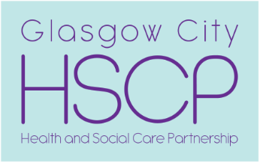

Nomination Form for Glasgow City Integration Joint Board Membership
Stakeholder Representatives

About the role

Time Commitment (approximate)
- 1 morning every 6-8 weeks for IJB meetings (Wednesdays, usually 9.30 – 12.30)
- 1 morning every 3 months for Public Engagement Committee meetings (Wednesdays, usually 10.00 – 12.00)
- 5-6 Development Sessions per year (days and times can vary)
- Time to read papers ahead of meetings
- Attendance at other events as a member of the IJB (optional).

Expectations on Members
- Attend consistently (members who miss 3 IJB meetings in a row for any reason other than illness may be removed from the IJB)
- Participate in meetings – ask questions, make comments
- Articulate the views and interests of the stakeholder group you represent
- Uphold good standards of behaviour in line with IJB Code of Conduct - https://glasgowcity.hscp.scot/standing-orders-code-conduct-and-declaration-interests.

Support available to Members
- Induction with HSCP officers
- Briefing available with HSCP officers ahead of IJB meetings to discuss papers and provide opportunity to ask questions or raise concerns
- Transport to meetings available (taxi arranged, or public transport costs refunded)
- Reimbursement of any expenses incurred as a direct result of IJB membership (e.g. cost of replacement carer cover or support worker time to enable participation).
Nomination form

*denotes required information, applications with these fields left blank will not be considered

Basic Information

Name*
Organisation*
Telephone*
Email*
Postal Address*
To which stakeholder group(s) do you belong?* | Circle / highlight all which apply  - Users of health services  - Users of social care services  - Independent sector  - Third sector

Statement in Support of Application

Please outline how you feel you could contribute to the Glasgow City Integration Joint Board and to the planning and scrutiny of health and social care services in Glasgow City. In particular you should describe any relevant experience in a personal, professional or voluntary capacity which shows your suitability for membership of the IJB. (statement should be no more than 800 words – approximately the size of the box below)

Completed applications should be returned by Friday 4th February 2022 to:

Email: GlasgowCityIJB@glasgow.gov.uk

Post: Julie Kirkland, Commonwealth House, 2nd floor, 32 Albion Street
Glasgow, G1 1LH

