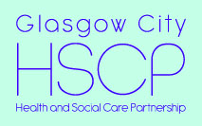

Glasgow City HSCP

Health & Social Care Partnership North East

Learning and Awareness Session

Thursday 17 January 2019 @ 9.30am

Reidvale Neighbourhood Centre

13 Whitevale Street

Glasgow G31 1QW

Programme

9.30 Registration, teas and coffees

10. 00 Welcome and introductions/objectives of the session - Gary Dover, Head of Planning

10.10 North East Hub - update and proposals - what the hub will include and estimated timescales for development - Gary Dover, Head of Planning

10.30 Moving Forward Together and implications for the hub - John Barber, Community Engagement Manager

10.45 Refreshments

11.00 Learning from previous projects (presentations and discussion):

- Learning from previous projects in NHSGG&C - John Donnelly, Senior General Manager and Andrew Baillie Project Manager, Facilities
- Experiences from the New Gorbals Health Social Care Centre - Hamish Battye Head of Planning and Strategy Older People’s Services and South Locality
- Glasgow City Council experiences - Jane Williamson, Glasgow City Council (TBA)
- What worked well in community engagement - Roy Greaterox and Sadie Gordon, North West Locality Engagement Forum Reps

12.25 Next Steps - Gary Dover, Head of Planning

12.30 Finish

Improving Services for North East Glasgow
Health and Social Care Hub
Summary

Introduction

The hub will be a focal point for a wide range of health and care services for both the east end and the wider north east of Glasgow. The primary objective of the hub will be to improve services for local people by providing fit for purpose and welcoming environment for services users/patients and our workforce. However, it will facilitate also the rationalisation of existing health board and council accommodation in the north east, enable investment to be focused on a smaller number of properties and support the longer term sustainability of our building infrastructure.

Current stage of development

We are at the Outline Business Case (OBC) stage. The purpose of this stage is to identify the preferred model for the hub. It should demonstrate that the preferred model optimises value for money and is affordable. Furthermore, it will set out the supporting commercial and management arrangements to be put in place to successfully implement that option. During the OBC stage the design team is appointed to prepare the design and construction costs for the building.

We have completed a selection process for the site of the hub. The process identified the Parkhead Hospital/Mental Health Resource Centre/Parkhead Health Centre as the preferred location. This has been endorsed by the Integrated Joint Board and by the Board of NHSGG&C. A report requesting support from the Council for the preferred site will be submitted to the City Administration Committee on the 16 January.

Strategic Context

The project is being developed within the context of the following strategies:

    - NHS Scotland 2020 Vision
    - NHS Quality Strategy
    - Health and Social Care Delivery Plan (2016)
    - National Clinical Strategy
    - Glasgow City Government’s Strategic Plan 2017-22
    - Moving Forward Together: A Transformational Strategy for Health and Social Care Services across Greater Glasgow and Clyde
    - Glasgow HSCP Strategic Plan 2016-19

Objectives for the project

- To improve access through a more natural flow of services and how they should be used (including shifting the balance of care from hospital to community).

- To improve performance across a number of services and themes to reduce inequalities for people living in the north east of Glasgow.

- To create better integrated teams and additional services.

- To improve safety and effectiveness of accommodation.

- To increase accommodation capacity and adaptability.

Services and buildings to be included in the hub

The hub will provide health and social care services for people from across the north east of Glasgow and, in addition, will include the services currently operating from Parkhead Health Centre. Based on discussions with stakeholders, including staff, services users, carers and partner agencies our proposal for a new health and social care hub will provide accommodation and clinical facilities for around 900 members of staff and include the following range of services:
    - GPs, dental, pharmacy
    - Specialist Children’s Services (CAMHS and Community Paediatrics)
    - Rehabilitation and enablement services
    - District nursing
    - Health visiting and school nursing
    - Social Work children and family teams
    - Older people’s mental health services
    - Learning disability services
    - Sandyford East sexual health services
    - Primary care mental health services and psychotherapy services
    - Health and social work Alcohol and Drugs Services
    - Criminal justice social work services
    - Health improvement services
    - Acute hospital services (especially outpatient clinics), such as chronic pain clinics, older people services, speech and language therapy, physiotherapy. A full list of acute services will be included in the final model and aligned with the recommendation of the Moving Forward Together Programme.
    - An integrated health and social care learning and development hub – City wide facilities
    - Community and third sector use of meeting rooms, such as a recovery cafe and space for mental health peer support groups.

Buildings that will be rationalised by the hub development

- Parkhead Hospital Mental Health Inpatients and Addiction services
- Parkhead Health Centre
- Community Mental Health Resource Centre (Anvil Centre)
- Sandyford Sexual Health Services
- Templeton – HQ and Children’s Services
- Newlands - Social Work and Addictions
- Parkview Resource Centre – Older people
- Brook Street – Social Work training
- Eastbank - Health Improvement offices

Benefits of the project

    - Improved access to services, particularly among vulnerable groups.
    - We will be able to shape more coherent patient pathways
    - For most people, the need to attend multiple locations will be removed.
    - Reduction in travel costs for citizens and travel costs to the organisation..
    - Staff time spent travelling will be reassigned to patient/service user-facing capacity.
    - Patients and service users will be more likely to access all components of their care plan if this can be done under one roof.
    - Pressure on hospital services will be reduced as new models of integrated services are introduced.
    - Population health will improve as connections are made more explicit about the impact that social, economic and environmental factors have on health outcomes and joint working and referral routes across statutory and voluntary sector organisations become more widely embedded.
    - We will decommission disparate buildings that are no longer fit for purpose.
    - Reduce revenue costs and capital charges in the future.

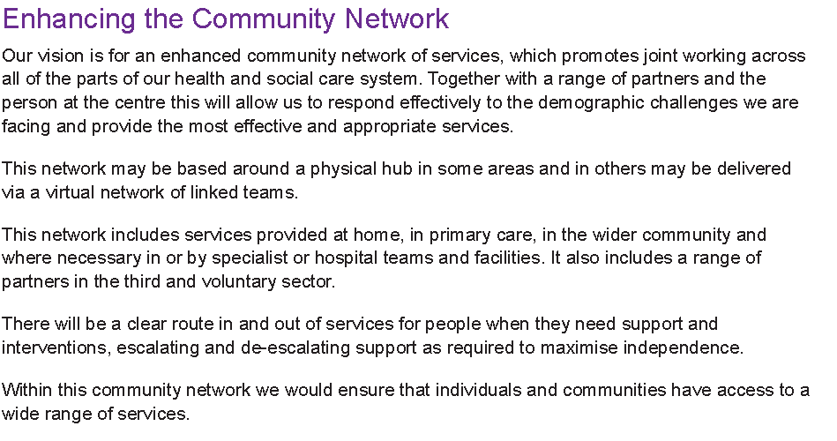

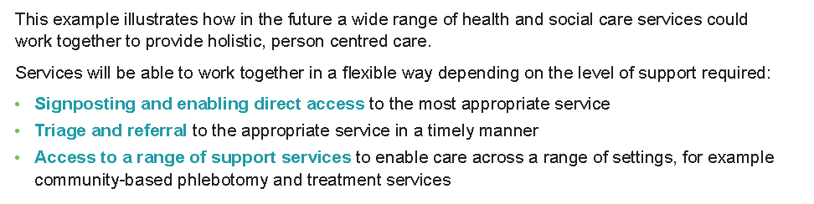
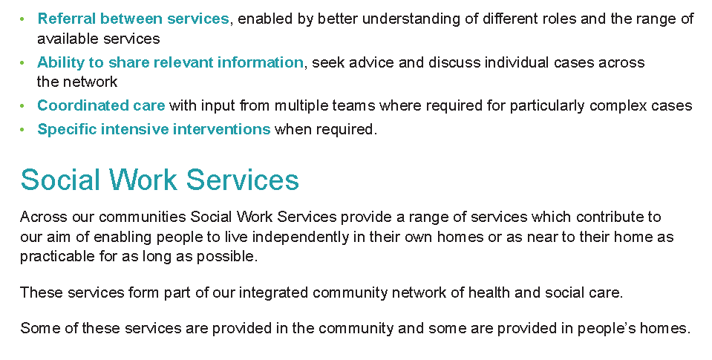

Stakeholder engagement

A public, staff and partner engagement exercise has been underway since March 2017 and will continue during 2019 as we develop the proposals in more detail. Some of the key themes from the engagement are summarised below:

- Overall support for proposals
- Services should be as local as possible
- Close to public transport
- Good parking facilities
- Bright and well lit, bright colours
- Good signage
- Open space with pot plants etc
- Background music and TV screen
- Office spaces allow personal choice in how you work
- Information, newspapers, magazines
- Something for children to do
- Welcoming staff and open area with manned reception
- Security - to avoid folk hanging around entrance
- Accessible for people with disabilities
- Flexibility to respond to changes in services
- Promote integration
- Spaces can be used by voluntary and community groups.
- Facilitating health promotion for staff, patients, local community

Draft project timetable

Stage | Estimated date
Submit Outline Business Case | October 2019
Submit Full Business Case | January 2020
Financial Close (if funded as hub DBFM) | May 2021
Construction | From June 2021 to 2023

Next Steps

- Agree preferred site – January 2019

- Finalise schedule of accommodation and requirements – January 2019

- Design team appointed – by February 2019

- Continue liaison with stakeholder agencies to obtain feedback on opportunities for co-location of services wider than health and social care.

- Continue to engage with local people and other local partners on the proposals – an engagement plan for 2019 is being prepared.

A summary of the key stages is shown below: Strategic Assessment – approved Initial Agreement – approved Outline Business Case (October 2018 to October 2019) Full Business Case Construction phase Monitoring and evaluation
Extracts from the Moving Forward Together report are shown in boxes in this summary to explain the service model that will be developed in the health and care hub.

