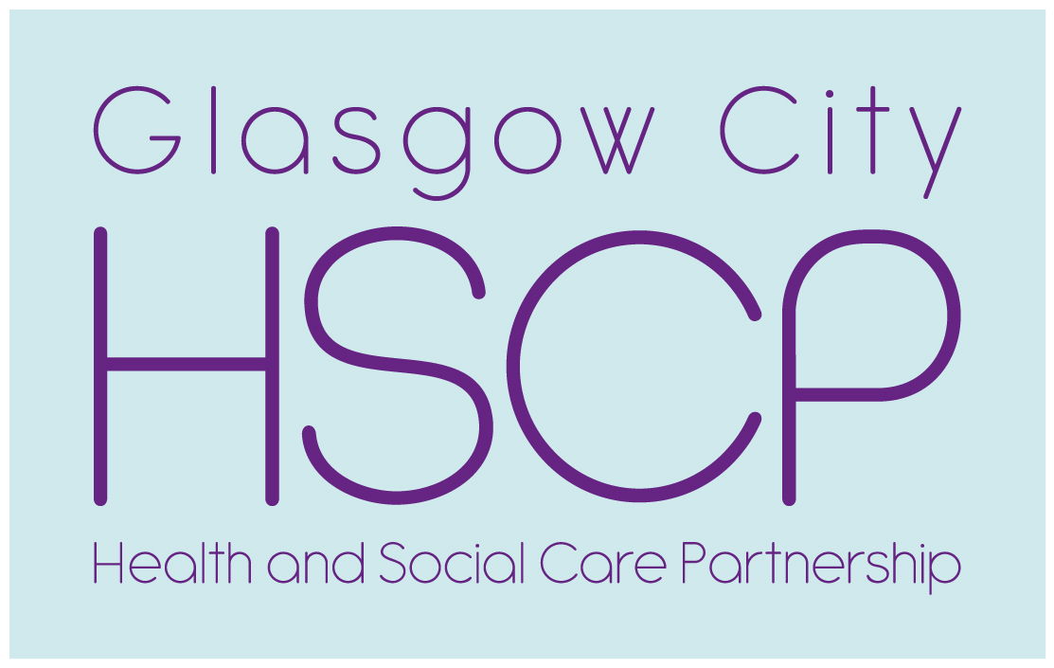

**North East Locality Engagement Forum Meeting**

**Thursday 23 May 2019**

**Time 6.30pm till 8.30pm.**

**Glasgow Kelvin College Haghill**

**Glasgow G31-3SR**

Present

Ann Souter (Chair), Morag Skinner, Jim Skinner, Lorraine Kennedy, John Ferguson, Marie Cairns, Charlotte Levy, Agnes Brisbane, Flo Collins, Mary Macpherson, Stephen McGuire, Billy Kirkpatrick,

In attendance

Gary Dover, Head of Planning and Strategy Children and Families.

Sophie Logan, Hoskins Architects

May Simpson, Community Engagement Officer.

Apologies

George McGuiness, Jamie McCarrion, Jacqueline Murphy, James Duncanson, Janette Whitelaw, Allison Lawson, Tony Devine (HSCP)

1. Minutes of the Locality Engagement Forum 25th April agreed.

2. East End Health and Social Care Hub Presentation

Sophie Logan (Hoskins Architects) started the presentation highlighting the previous projects the firm has completed including Eastwood H & CC, The Bridge (Easterhouse), National Theatre workspace, National Museum (Edinburgh) etc and the firm are familiar with taking a project from concept to design to completion. A great deal of information, ideas and opinions have been gathered via focus groups, service user, patient and staff engagement, Community Councils, recent workshops and site visits and the Parkhead and wider East end community engagement.

There is a further two workshop scheduled for Thursday 30 May and Thursday 13 June 2019 in Eastbank, Shettleston. Action: contact Tony for more information.



The information gathered so far was:

* List of services requiring accommodation, including GP’s, Children’s services, physiotherapy, podiatry, office and training space
* Sense of welcoming and friendly
* Clear front door/entrance
* Good, easy ‘way finding’ – it’s a big building we have to avoid long corridors, poor flow etc
* Adaptable and flexible accommodation – ‘future proofing’
* Compatible service locations within the building – the right services next to each other which can deliver additions benefits for patients

The design concept so far:

* Location – Parkhead
* Entrance onto Duke Street (opposite The Forge) with car park entrance at Nisbet Street and drop off being at Salamanca Street
* Design – off set square figure of 8 with 2 internal courtyard, private green area at rear and planting at front/entrance. The front square would be 3 storeys high and the back square would be 4 storeys.

The following questions and points were noted:

* Transport and access to the location – it was felt that bus companies should be involved. Gary advised a Travel Plan was a requirement for the planning application.
* Enthusiasm for the building operating longer than core 9-5.30 traditional hours to help deliver more services and make the building a true Hub of community involvement for the NE of Glasgow
* The design of the new building is that it will provide flexible and can be adaptable for a number of services.
* Members were pleased that the community would have access to community rooms in the building.
* It was noted that the new building will not have an X-ray machine
* The two existing GP Practices in the Health Centre would be moving into the new Hub. Letters were sent to all the GP Practices in the surrounding area to invite them to move into the new Centre.
* A number of points were raised about car parking – capacity, access, use during Emirate events or Football games
* Discussion around obtaining more land for parking if TA requires additional parking spaces than the site can support
* A huge thank you to Gary Dover from Ann for the many years work he has undertaken to get to this point and a real enthusiasm from the group to be involved as the project develops.

3. Older People’s Transformational Change Programme Event – 14 May 2019

The following comments noted:

* Interesting event with good attendance - 35-40 people
* East end focus for older people’s services, good range of stalls and inputs – Fire Brigade, Older people’s services, telecare, Hording, Pharmacy services, Mental Health Services in the North East,

Discussion on the role and benefits of GP Link workers but it was not every GP Practice has a Link worker. The changing role of GP’s was discussed and benefits of social prescribing.

4. AOCB

Suggestion and potential topics for future meeting:

Audiology, X ray services and changing GP services

Date of Next Meeting:

Thursday 27 June 2019

Time 6.30pm till 8.30pm

Venue Glasgow Kelvin College Haghill

If you require any more information, please contact Tony Devine.

Telephone 0141 277 7554 Mobile

0777 265 4641 [tony.devine@ggc.scot.nhs.uk](mailto:tony.devine@ggc.scot.nhs.uk)