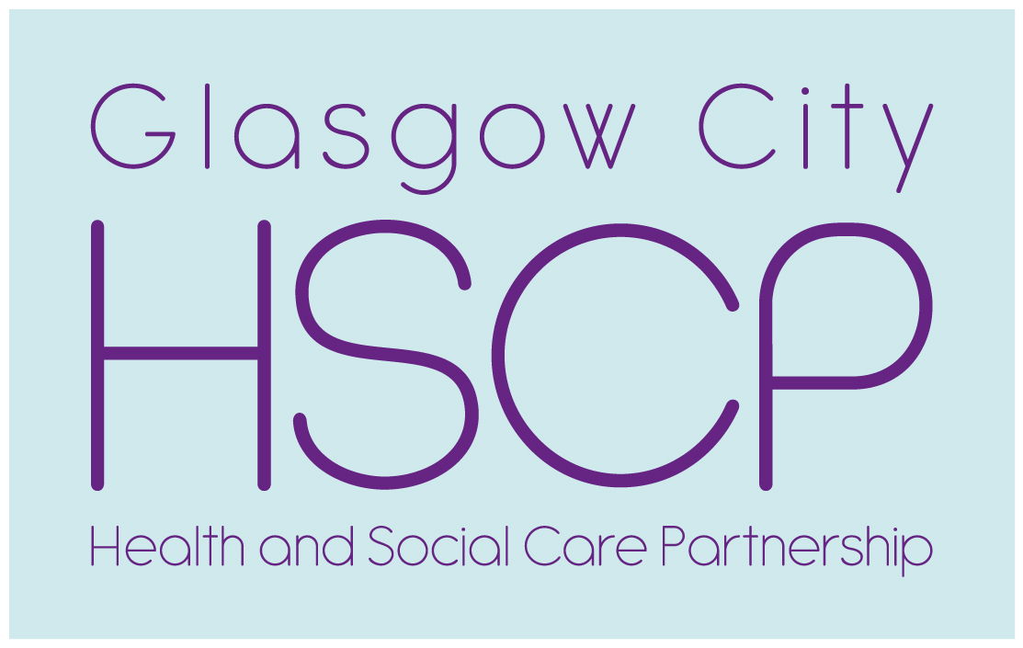

**Locality Engagement Forum Meeting**

**Thursday 27th of June 2019 Time 6.30pm till 8.30pm**

**Glasgow Kelvin College Haghill 2 Haghill Road G31-3SR**

**Item (1) Testing the proposed Communication and Engagement Campaign to stop walk ins to the GP OOHs Service Presentation**

**by Kirsty Orr Project Manager on the Review of Health and Social Care Out of Hours Services**

The review proposes changes to how the public access GP OOHs services The rest of Scotland all patients who want to or need to access a GP during the OOHs period must contact NHS 24 in the first instance this allows NHS 24 the opportunity to direct patients / carers to other parts of the service which may be more appropriate e.g Pharmacist for a repeat prescription or minor ailment.

Greater Glasgow and Clyde are keen to introduce the same process as the rest of Scotland. Kirsty explained the changes to the Forum on February this year members were keen to see a robust public education campaign to inform the public about what services were available and when they should be accessed.

Kirsty will explain the engagement programme and members are asked for their comments.

**Item (2) Report from the Older Peoples Event Tuesday 14th May Parkhead School House (copy attached)**

**Item (3) Locality Forum Meeting Dates for second half of 2019.**

**15th August, 19th September,  31st October,  12th December.**

**Always Thursday Time 6.30pm till 8.30pm**

**If you require more information, please contact Tony Devine.**

**Telephone 0141 277 7554 Mobile 0777 265 4641**

**Email** [**tony.devine@ggc.scot.nhs.uk**](mailto:tony.devine@ggc.scot.nhs.uk)

