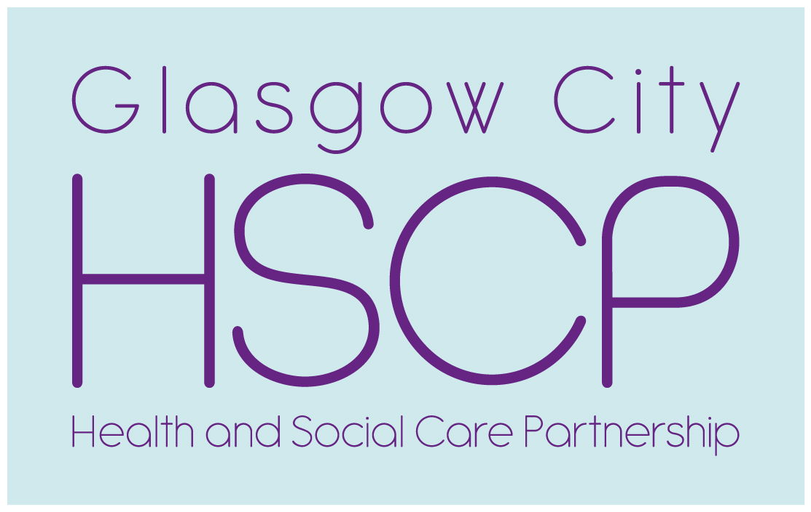

**North East Glasgow HSCP and Parkhead Housing Association**

**Older Peoples Event**

**Tuesday 14th of May 2019 Time 10.30am till 1.pm.**

**Parkhead School House 135 Westmuir Street Glasgow G-3SR**

**Background**

North East Glasgow’s Older Peoples Working Group (OPWG) receives regular reports on the progress of the two major policy developments impacting on the service provision for older people. Nearly 40 community and voluntary sector representatives attended, discussed and gave feedback on their service priorities for the North East Locality.

Moving Forward Together Programme is to develop and deliver a transformational change in service provision providing safe effective person centred, accessible and sustainable care to meet the current and future needs of our growing population.

Primary Care Review - The Scottish Government has introduced a new contract with GPs in response to growing pressures within primary care. The aim of the new contract is to enable GPs to operate as “expert medical generalists”. This will be achieved by diverting work that can best be done by others, i.e., pharmacists, optometrists; community links workers, leaving GPs with more capacity to care for people with complex needs.

The session format was a series of presentations with the emphasis on community based services followed by a question and answer session, there was also a number of information stands covering a range of both statutory and third sector partners.

Fiona Brown Head of Older People and Primary Care began the session by explaining the range of Health and Social Care Services designed to help people stay in their own home including. Neighbourhood Teams, Carers Strategy, Supported Living Developments, Housing Options for Older People, Home is Best Team.

**Question:** How long does this process normally take?

**Answer**: 6 weeks when alternative housing is required, the Housing Associations are normally very good at finding more suitable accommodation for people who require it.

In general there is a 72 hour target in place when patients are declared fit for discharge.

**Question:** Why are people referred to Health Centres far away from where they stay for services such as Podiatry?

**Answer:** This could be due to the high volume of patients requiring those services; however every effort should be made to allocate appointments for people as near as possible to where they stay. Fiona will raise this with the lead Podiatrist.



Second presentation was from Laura Hannigan Prescribing Support Pharmacist

Laura explained growing role of the community pharmacists in many of our local GP Practices, what it will look like and what it will mean for service user.

**Question**: what is the main difference between GP pharmacies and community?

based services?

**Answer**: GP pharmacies will be able to provide medication reviews, whereas community based pharmacies mainly provide a minor ailments service

**Question**: Will there be continuity of staff in relation to pharmacy services?

**Answer**: Yes in the GP setting, however it is more difficult to guarantee in the community due to the turnover of staff. By 2021 there will be pharmacy services in every GP surgery provided by the Health Board.

Services that Pharmacists are asked to provide can vary in the summer lots of skin complaints, strings minor cuts turning septic, winter more coughs colds flu symptoms.

Third presentation was from James Jordan Utilising health technology to support better care in your own home Telecare service.

The Lifeline Alarm service has been designed specifically for the elderly, frail and disabled, to ensure that they can live safely and independently in their own home.

The system is also recommended for people of any age who suffer from a medical condition or disability. The alarm is particularly helpful for those who are at risk of a fall and those with a medical condition or disability

**Question** How do you refer?

**Answe**r For the basic system (alarm unit and pendant) the service user or someone on their behalf can complete a telecare form from the website <https://www.glasgow.gov.uk/CHttpHandler>. or alternatively call telecare on 276 5615.

**Question** How much does it cost?

**Answer** It costs £3.38 per week for the service.

**Question** How long does take to be assessed?

**Answer** From receiving the application it takes around 7 – 10 days to install

For the additional/extra devices such as fall detectors and door alarms, it usually part of a Social Work /health assessment, this can take longer.

The last presentation continued with the Home is Best theme James Scott

from the Fire Service Community Action Team based at Carlton Fire Station

gave fire home safety advice provided leaflets, information generating a number of future home fire safety visits.

Fiona Brown Head of Older People and Primary Care closed the session by thanking the various partners for their and contribution, the Mental Health Network, Community Link Workers, Marie Curie, Fire Service, and Parkhead Housing Association who supported the session through Maureen Smith Housing Officer and provided the venue and hospitality.

Tony Devine Community Engagement Development Worker North East Sector HSCP.