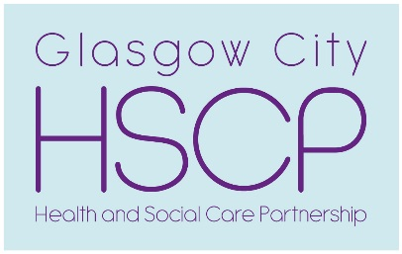
North West
Local Engagement Forum

Thursday 30 November 2019

10.00am – 12.30pm
Social Work Office, 17 Gullane Street, Partick, G11 6AH

DRAFT Agenda
Welcome and Introductions (Robert Smith, Chair)

- (a) NW LEF Minutes – 26 September 2019 10.00 – 10.10

(b) NW LEF Report – 15 October 2019 and Summary of NW Locality Plan 2019- 22

- Review of Communication Strategy(Jason Mokrovich, Business Dev Manager and Debbie McGarrigle, Principal Officer HSCP) 10.10 – 11.00

Tea Break 11.00 -11.15
- Royal National Institute of Blind People (RNIB) (Gozie Joe Adigwe, Community Facilitator – Diversity Lead) 11.15 – 12.00

- Programme 2020 12.00 – 12.15
- 16 Jan 2020 @ 10- 12.00 in Albany Centre– Review of Participation and Engagement Workshop
- 30 January 2020 @10.00- 12.30 in Albany Centre - Update on GP/Primary Care Services and progress report on Review of Out of Hours Services
- 27 February 2020 @ 10.00- 12.30 in Gullane Street - Learning Disability Services
- 26 March 2020 @ 10.00- 12.30 in Woodside Health and Care Centre

- AOCB 12.15 – 12.30
(i) Power of Attorney Day - 20 November 2019
For more information or to become a member of NW LEF contact: May Simpson, email: May.Simpson@ggc.scot.nhs.uk or Tel 0141 314 6263.

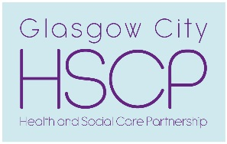
Draft Minutes of NW Locality Engagement Forum Meeting held on 26 September 2019

Attendance
Robert Smith Alan McDonald Ann Kilgour Winnie McPhail
Mary McShane Sadie Gordon Muriel Anderson Lilian Woolfries

Apologies
Rita Hepburn Abdul Benjelloun Gordon McInnes Alan Gow
Mr Jamil Janice Walker Nicky Neilson John McVicar
Mark McBay

In Attendance
Colin Mitchell, Barclay Medical Practice, Patient and Project Manager
Vikki Murray, Barclay Medical Practice, Patient Involvement Manager
Margaret Black, NW Locality Primary Care Development Officer
Lorna McIlreavy, Scottish Health Council
Craig Cowan HSCP, Business Development Manager
Steven Blair, HSCP, Principal Officer, Business Development
May Simpson, NW Locality, Community Engagement Officer

Robert Smith welcomed everyone to the NW Locality Engagement Forum meeting. He advised members that Jean Dougan had resigned from the LEF due to ill health. On behalf of the group Robert thanked Jean for her involvement and commitment to the LEF over a number of years.
1 | Minutes of NW LEF – 22 August 2019 – agreed.  Matters Arising – none
2 | Barclay Medical Practice: Victoria Park – Proposed Closure of Yoker Branch. (Colin Mitchell, Barclay Medical Practice, Patient and Project Manager and Vikki Murray, Barclay Medical Practice, Patient Involvement Manager)  Colin provided members with the background and rational which has led to the proposal to close the Yoker Branch of the Victoria Park GP Practice. The single handed GP at the Victoria Park practice had approached the Barclay Medical Practice, which has a large practice in Maryhill Health and Care Centre, practices at St Georges Cross, Glasgow University and three practices in Lothian, to join the larger group of practices. The Victoria Practice is now part of the Barclay Medical Practice group.  The Victoria Park practice main surgery is located at 1398 Dumbarton Road with a branch surgery, which was operated on a part time basis, at 2452 Dumbarton. The branch property is leased to the Victoria Park practice and the owner notified the practice they wanted to sell the property at 2452 Dumbarton Road by the end of the year. The distance between the branch and the main surgery is 6 bus stops and the route is serviced by several frequent bus services.  There is proposal consolidate and improve services at the main surgery and invest in the fabric of the building to improve access and comfort for patients as the Practice patient profile is 60% elderly. A survey was sent to each patient in the practice and of the 300 patients who responded 20 people said they would move to another GP Practice. The majority of comments recorded highlighted the need for investment in the surgery and access difficulties (60 people). Of the patients who returned the survey – 40 identified themselves as housed bound and the Practice phoned these patients to reassure them that they would continue to get ‘house calls’.  Members were reassured there was adequate provision in other GP Practices in the Yoker area for the patients who wished to change GP or did not wish to travel to the main branch. All the GP practices in the Yoker area have ‘open’ lists.  Members highlighted the need for ‘trust in the GP and Practice’ which has been built up over many years. Colin and Vikki acknowledged that this was very important and Practice will develop new services, similar to the model adopted in the Barclay group’s other practices. The example given was multi disciplinary Teams giving patients access to a range of specialist services such as physiotherapists.  The consultation carried out by the Practice closes on 1 October 2019 and the HSCP consultation with key partners ends on 10 October 2019. All the information gathered will be sent to the Greater Glasgow and Clyde Health Board to contribute to the considerations on the proposal to close the Yoker branch.  Robert asked ‘what is the point of the consultation’ when it was likely the decision to close the Yoker branch was already made. Colin advised that it was a way of communicating with patients and allowing the Practice to prepare for the impact of the proposed change.
3 | Review of Strategic Planning Groups and Participation and Engagement Structure in the HSCP(Craig Cowan and Steven Blair, Principal Officer HSCP)  Craig provided the meeting with the background to the Review which will find out what works well and what needs to improve as well as listing all the element that were being reviewed:  - Participation and Engagement Strategy  - Strategic Planning Groups  - Locality Engagement Forums  - Public Engagement Committee  - Communication Strategy  The aim is to complete the review and present the updated Strategies to the IJB in June 2020.  Craig highlighted that a common response to the recent Strategic Plan survey was that ‘the HSCP make decision and then tell people what they have decided’. Another common comment gathered via the survey was that ‘the Strategic Planning Groups have very few public members on them and there is little connection with the LEF’s’.  There was some strong opinions expressed about the Public Engagement Committee – ‘waste of money’, ‘majority of people in attendance were officers’, ‘not interested in ‘joe public’ opinion’ ‘not really engaging with the public just talking amongst themselves’ and ‘agenda had little on it that would interest the general public’. Some people felt the Committee paid ‘lip service’ to the Localities with only 10 -15 mins at the end of each meeting to discuss Locality work. Craig advised that the structure and agenda had to accommodate legislative responsibilities. There was also some misunderstanding due to the name of the committee – it is Business meeting of the work of the HSCP – it is not a public engagement Forum.  AMcD felt that people needed to know more about the IJB and about the structure and how to get involved. He also thought that 3 years is enough time to see an improvement – but he hasn’t seen an improvement in services or engagement.  SG felt that the public is often told services and developments need time to ‘bed in’ but questioned when are we going to see progress and results? Also there seems to be continual reviewing of structure and services with no improvement, progress or results.  Craig advised that the IJB had recently been assessed and a self evaluation exercise had been completed by the IJB. RS highlighted that there were only 3 community representatives on the IJB and it was impossible for them to represent the City and there no mechanism for these representatives to feedback to LEF or the wider community. RS felt there needed to be more community represents on the IJB. Craig detailed the membership of the IJB which is set out in legislation.  Some members felt that the HSCP needed to improve how it communicated with the public the discussions and decision made by the IJB – not just put the minutes on the website. MS advised that at the LEF meeting in November there would be time to discuss in detail the Communication Strategy as it was on the agenda.  LMcI cited examples of committees that ran with ‘lay’ chairs and a jointly set agenda rather than agenda being set by officers. LW felt there was ‘too much going on’ and it was difficult to keep track of changes or when proposal ‘slipped’ off the agenda or were not being progressed as promised.  There was then a discussion regarding the Strategic Planning Group. It was felt it was ‘top heavy’ with senior managers and little or no information came from these groups to LEF members. Members asked if there was cross over or links between all of the Strategic Planning Groups, how lay representatives were elected onto these groups, how often they met and are the minutes available to the public? Craig advised that these were all areas that the review would cover.  Craig advised that the review of LEF would be completed by the end of the year. MS encouraged the LEF members to self evaluate and review the LEF structure, members, outcomes etc. AMcD suggested an focus group/meeting with LEF members and key partners and representatives in the in the community (Carers Forum, Youth Network, Mental Health Network, Thriving Places, Recovery Communities, Childcare Forum, key 3rd Sector etc) to examine engagement and participation with the HSCP.  Action: May Simpson, Craig Cowan and Steven Blair
5 | Reports  - NW OPPG Report – 25 September 2019 – verbal update  MA and SG advised that one of the proposals from the work around the roll out of the Neighbourhood structure for older people’s services was to develop Neighbourhood Networks. The remit, membership and work of these Networks are still being developed but the ambition is they are the link to the local resources and assets in the community/neighbourhood.
AOCB
- 15 October 2019 @ 9.45- 12.45 – in Albany Centre focusing on the NW Locality Plan 2019- 22. MS reminded members of the next meeting was for the wider NW community and asked members to encourage participation from their group members.

Date of next meeting: 28 November 2019 @ 10.00 – 12.30 – Training Room, 17 Gullane Street, Partick
North West Locality Plan 2019 – 22
Engagement Event Report

15 October 2019 in Albany Centre, 44 Ashley Street, G3 6DS

Introduction
On the 15 October 2019 in the Albany Centre, 34 representatives from the NW Locality Engagement Forum, 3rd Sector Projects, the wider community attended an engagement event with Glasgow City HSCP – North West Locality senior management team to consider and discuss the North West Locality Plan 2019 -22.
The session was opened by Jackie Kerr, Assistant Chief Officer (NW Locality & Adult Services), with a presentation covering the HSCP Strategic priorities and the challenges facing the partnership along with some of the plans and actions that would address these challenges over the 3 years.
Janet Hayes, (Head of Planning and Strategy - Adult Services and North West Locality) provided the audience with a profile of the area, a breakdown of North West Locality annual budget and achievements, so far, in the first year of the plan. Julie McCarthy (NW Locality, Health Improvement Lead) then detailed the work and key priorities of Health Improvement Teams to tackle health inequalities and improve health.
There were four presentations were on key service priorities
- Adult Services Locality Priorities(1) – Sexual Health Services, Police Custody Prison and Health Services (Rhoda McLeod, Head of Adult Services)
- Children’s Services - Locality Priorities (Karen Dyball, NW Locality, Head of
Children’s Services)
- Adult Services Locality Priorities (2) – Mental Health, Alcohol and Drug Recovery Services, Learning Disability Services (Colin Mc Cormack, NW Locality, Head of Adult
Services)
- Older People’s Services and Primary Care Locality Priorities (Paul Adams, NW Locality, Head of Older People’s and Primary Care Services

The comments, questions and feedback from the facilitated discussions on each of the service areas are detailed in the next section of this report.
All the power point presentations from the session are available at: https://glasgowcity.hscp.scot/north-west-locality-engagement-forum and draft Locality Plan 2019- 22 Report is available at: https://glasgowcity.hscp.scot/sites/default/files/publications/ITEM%20No%2012%20-%20Draft%20HSCP%20Locality%20Plans%202019-22.pdf.

Summary of Group Discussions

Sexual Health Services, Police Custody Prison and Health Services

Comments
- The move to an online service for services is positive.
- Important to have more flexible opening times for younger people to attend sexual health services so they don’t have to miss school. Welcome return to a service that was previously available to young people.
- Good that there is a focus on improving services for young people and good idea re young people’s services and social media.
- Discretion and privacy of access to services important.
- Consultation important and has worked well around sexual health services.
- More information on the real numbers attending services, how many under 18s access the service, who uses services from deprived areas and what is the criteria etc would give a better understanding of sexual health service demands.

- Mental health workers in police stations is very good development.
- Community unit for women is a really positive development and will hopefully reduce mental health issues and avoid criminal justice trajectory for some of those who will be accommodated in the unit.
- Trauma informed working - Glasgow Council on Alcohol are planning to develop support to work with people in Police Custody Prison

What is missing/discussion points noted
- The work with Archway looks really positive but would like more detail in the plan about ‘wrap around’ service for vulnerable group of people.
- Removal of sexual health service from Drumchapel will be missed.
- Obligation of community to look after themselves – with the support of Health Improvement services.
Q What is the community engagement plans with local people regarding the buildingof new Community Custody Unit at Maryhill?
- Consultation required around Women’s custody unit.
- The new unit will be more open and work with women in an integrated ‘throughcare’ approach to reduce risk of re offending.
- Custody needs to be joined up a two way process as offenders, especially women offenders, are a really vulnerable group of service user.
Q Do the police link with youth service re offending and is there working going on in schools to build resilience in youth people?
- Former offenders with lived experience can offer peer support to change behaviour.
- Need to reform and improve prison – Barlinnie is not fit for purpose – traumatising. We need to address addictions in prisons, provide health improvement and pathways into health services for people leaving prisons.
- Importance of good communication between services in the community and the prison service to improve aftercare.

Children’s Services

Comments
Q Is the reduction in ‘out of Glasgow’ placements for purely financial reasons? Do we have the infrastructure within the city to support that change?
- There are 140 places in 8 bedded HSCP managed children’s units in Glasgow which helps with bringing ‘looked after’ young people back into Glasgow and save money. The HSCP also hopes to reduce the number of young people being ‘looked after’.
- Priorities look good – we need to make sure young people remain in their community.
- Positive feedback re the work being done around keeping children at home and in their own communities avoiding residential care (2 similar comments)
- On paper you couldn’t argue with the priorities – the approach re person centred, real figures, trying to achieve personal outcomes and keeping children in their own community is all good.

- 3rd Sector has a lot to offer/Good work being done across the third sector
- We are heading in the right direction ad should continue to take on board what voluntary organisations can provide.
- Communication is critical - we need to break down our own barriers / perceptions. Making links is challenging and requires having the time / capacity to do so. It was noted that there is sometimes a reluctance to share good practice – especially regarding the voluntary sector organisations wanting to retain knowledge to support future funding. Need more in the way of locality forums to share learning, and it should be a funding requirement to attend / participate. Barriers to involvement need to be reduced.

What is missing/discussion points noted
Q Can Health Visitors ease the role / scale of Social Work input – they are such different roles? Is there a risk that in fact greater need for Social Work input will be identified?
- It was noted that the HSCP have funding to employ more health visitors but due the age profile of the workforce (staff retiring) and not enough suitably qualified staff. The HSCP had to ‘grow’ the work force through training and working with colleges/universities.
- Emphasis should be on positive parenting.
- Its good there are plans that the HSCP plan to work closely with 3rd sector but the 3rd sector need resources as often voluntary projects are first to lose funding.
- The use of heroin has reappeared – mostly in the South of the city – especially in young people. Third sector funding cuts resulted in a Health and Prevention team being cut.
Q Does it require a 3rd sector map within the plan and updated regularly?
- ‘A journey’ not a quick fix. Should aim to reduce referrals to Children’s Panel – emphasis on family support.
Q What resources are being put into helping young people getting involved in criminal or violent behaviour? There is partnership work with 3rd sector to work with and support families/young people. Health visitor also support vulnerable families.
Q What is the wrap around service connecting adult support and support going to children – they have to be linked.
Q How do the HSCP work with third sector youth projects? It was noted that the HSCP work with the 3rd sector Consortium and recently carried out a consultation with voluntary sector re Family Support service. It was felt that although the HSCP are freeing up resources through in having more ‘looked after’ placements in the city the money re invested (support at the weekend and in the evening for 12 + years) is awarded to larger 3rd sector (Bernardo’s Includem and Action for Children) – not smaller local projects working in communities support families and vulnerable young people. There were also worries about the administration costs, time taken to make these funding awards and short term funding was also expressed.
- Often young adults are referred into services and it is clear that they have not had help timeously in their adolescence – it is key to address this issue to support what is truly preventative work.

Q CAMHS – significant waits for service – do they need additional funding? Are there other services for children in the way that there are alternatives for adults?
- There is no specific service or counselling for young people whose parents are affected by alcohol.
- Concern that there is not enough counselling services or there are waiting lists for counselling services for young people too long. Lifelink only work with young people assessed with ‘mild to moderate’ needs but young people assessed with moderate to approaching crisis needs have a very long time to wait for a service via CAHMS. It was noted that there is money for counselling service but the HSCP have to ‘grow our own’ as there is not enough suitable qualified counsellors.
- The HSCP should work in partnership with the 3rd sector more as they often offer/support counselling courses. This type of partnership also contributes to promoting employment and addressing poverty in our communities.
- It was noted that 3rd sector organisation find it relatively easy to attract money for training but don’t have the funding to employ permanent counsellors once they have been trained. 3rd sector have to employ counsellors on a sessional basis which make it harder to retain staff and provide continuity of service. It was noted that there is often the expectation that trained voluntary counsellors will provide a service on a voluntary basis but this expectation is not realistic.
- Many statistics and studies have shown that poverty plays a huge part in family breakdown which can result in children being looked after away from the family home. If there was better access to counselling services and family support – this may reduce the number of children requiring a social worker and reduce the number of children being ‘looked after’.
Q What are we doing about counselling – a lot of primary school children now need this – do we know why?
- It was noted the Scottish Government has just announced there will be £2M directly allocated to the Education Departments in Scotland for counselling for children from Primary 6 to secondary school age. The funding will be available this year 2019-20 and the aim is that every school in Scotland will have access to counselling services.
- The HSCP works in partnership with the Education Department - joint money – to support young people and improve educational attainment.
- More information around ‘Looked After Children’ and difficulties regarding educational attainment and links to youth homelessness and is there a difference from care system and kinship care attainment?
- Specialist Children services info missing such as CAMHs and Physical Disability children services is missing from the plan

- Inequity across HSCPs at Board level – e.g. in the way resources are allocated – therefore need to address postcode lottery of some services.
- Recognition of ‘adverse childhood experiences’ (ACES), deprivation and inequalities – impact the have on children
- Hidden need in affluent areas – isolation, hidden poverty.
- Political solution required - have to be mindful of wider societal issues
- Inequality gaps – generational (endemic in certain areas of Glasgow)
- Have to tailor services to meet diversity of population
- Services should be needs-led not age-led.

Q Should be an option to not take a baby box?
- Homecare – not easy to complain and don’t receive feedback
- Carers at home with those they care for – need more advice
- The mention of transition to Adult services within plan is needed.
Mental Health, Alcohol and Drug Recovery Services, Learning Disability Services

Comments
- The move away from hospital beds to community support is a good thing.
- The increase in Community Link workers should improve the links with primary care and therefore access to mental health services.
- Mental Health - peer-led service development is a good idea.
- Happy that the plans for the crisis cafe with an outreach service are on schedule to be in place before the end of the financial year. The location has not been identified yet as it will depend on which provider which secures the commission.
- It would be helpful to qualify what 18 week response to service means? Is it first appointment or first treatment for treatment?

- Re- assured that there is continued funding for Recovery Communities

What is missing/discussion points noted
- Mental Health services - there is nothing in the plan about young people transitioning into adult services – why not?
- Transition from Adult to Older People’s Mental Health services should be mentioned in the plan.
- We should be aiming for good support services and good access - 24/7 – not just focusing on the ‘out of hours’.
- We need to make service fit people – not the other way around
- Mental Health 5 year plan priorities and ambitions – are too ambitious – it was felt the HSCP was setting itself up to fall and that some of the priorities were not achievable in 5 years.
- If GP’s find the referral and pathway for Mental Health services difficult to navigate – it will be difficult for the general public to access services. Need to make access more straight forward.(2 similar comments)
Q Is there a training package for GPs / other referrers in relation to services available?
- GPs should prepare patients before accessing services.
- Communication of / about services is a major issue – people do not know what is available or how to access it – whether as patients or referrers.(2 similar comments)
- IT systems should linked with each other – so there is a assessments/basic information.
Q Is there one referral list for Adult services and Older People’s Mental Health services? It is harder for older adults to access Mental Health services
- Need transport to get people to services that are in our communities – to avoid isolation and loneliness.
- Do we over medicalise care and treatment – more emphasis on other forms of intervention.
- Third Sector – appropriate and positive that we work with them to keep people at home.
- Access to services for people with co-morbidity should be detailed in the plan as a priority in order to ensure person is not being moved from pillar to post.
- Support workers in Learning Disability need to be valued more – the salaries are too low and organisations find it difficult recruit and retain staff.
- Third sector find it difficult to retain staff due to the short term funding structure and low wages for staff - the impact is no continuity of care. For someone with a mild learning disability with minimal support a common experience is that care workers/voluntary organisation keep cancelling support sessions as they are not seen as a priority.
- The HSCP say the third sector is a really important partner but don’t pay the full costs for the service they want to provide.
- Some preventative services – for example Fortune Works – are being take seriously as they form part of the engagement of service users who may not otherwise engage with HSCP services.
- Positive feedback with regard to our work re carers from Enable Glasgow
- If third sector have more innovative ways to help people - then that is positive and the HSCP should support and pay for to allow to happen.
- Can see the value in what the HSCP are doing as the ‘experts’ but partnership with voluntary sector is crucial.
- People with learning disabilities are disenfranchised due to lack of support – they want to be a part of society.
Q Do we still have a needle exchange and if we do, is the service as accessible as it should be?
Q Is there scope for this service to be provided by pharmacists?
- Services have been reduced as funding has decreased, so gaps in services and support has increased. Referrers need more time to navigate between the available services. Access needs to improve.
- Drugs and Alcohol levels need addressed – affecting local communities.
- Addiction can be visible and invisible to the community.
- Many people in Barlinnie have drug related crimes.
Q Is legalising drugs a solution?
Q Why are people on a methadone programme - kept on it for so long – what are we doing about this?
Older People’s Services and Primary Care

Comments
- Working in neighbourhood model is a good idea (2 similar comments).
- Older people discharged for hospital – there needs to be more investment in the community supports offered by both small and large organisations. The greatest asset is the community and the supports they offer – as demonstrate by Knightswood Connects.
- There has been a loss of services in some areas but we can use other assets – for example the lunch club at Lambhill Stables, local church halls etc.
- Services need to be more integrated.

- Welcomed engagement with partners (e.g. Housing etc) to raise awareness with communities on how to use health and care services.
- Services should be needs-led rather than age-led, e.g. how do services reflect the premature aging effect in areas of deprivation?
- Importance of health promotion and positive lifestyle choices.
- HSCP sometimes put money into areas but more individuals should ‘do it for themselves’
- It is positive that the delayed discharges targets (apart from patients with capacity issues) are they being met.
- Need to make sure figures in the Locality Plan are understandable.
- The idea to take routine work away from GP’s is good but need change in culture and behaviour of public and have appropriately trained/qualified workers in place.
Q Difference in residents and GP registrations – how is this accounted for in planning and funding services?
Q More ‘links-type’ workers are needed and could the benefit of these resources be shared amongst clusters or more widely across neighbourhoods – e.g. the learning and knowledge they have of local assets?
Q What is the evidence base for some of the service priorities e.g. the Community Links Workers, and also how they are allocated – postcode lottery?
Q What benefits from austerity - can you use and learn for in the future as landscape changes?
What is missing/discussion points noted
- Target to reduce delayed dis-change is a good aim but need good communication and appropriate supports in the community in place to make it work well.

- ROAC – very few older people attend the Recovery Communities – the emphasis is still on drugs and not alcohol. Drink Wise, Age Well is it final year of funding. Is there a stigma attached to older men seeking help with their alcohol addictions.

- Dementia diagnosis – should be a trigger for Anticipatory Care Plan. Important to have Anticipatory Care Plan’s accessible for services.
- There are gaps in dementia trained staff in care homes and hospitals.

- Lots of pilot projects are successful but never rolled out – example- Knightswood Connects. Why don’t the HSCP decide what they want to do, make a plan and implement the plan - rather than pilots that don’t get rolled out across the city?
- Knightswood Connects flagging up that older people access service differently – it was noted that the roll out the Neighbourhood model for older people services will use the expertise and learning gathered in Knightswood Connects project.
- If the move is to a Neighbourhood model for older people services and it works – it should be adopted by other services such as Mental Health, Children’s services etc.
- All services should be provided in all areas – not necessarily in exactly the same way, but there should not be services that are simply not available to some residents of the city.
- Need consistency of model over time - services / structures change all the time and this can be de-motivating for staff and for partner organisations.

- Transport is still a big issue for older people in accessing services – the bus routes don’t go into the schemes - they go the main roads. My Bus is OK but there is a lack of them and the criteria is quite restrictive. It was noted that transport is always the number one issue identified in any survey carried out by Community Planning Partnership/Area Committee.
- Need for more community facilities – Men’s Sheds in NW Glasgow, libraries etc
- More tailor support to individuals
- Elderly carers has been assisted/better support with the introduction of emergency planning - a positive step
- Still wait too long in some GP surgeries to get an appointment.
- Need to free up GP capacity – scope for technological solutions.

General Comments

Feed up with continual reviews – the HSCP should just get on with the job. These continual reviews must have an impact on staff morale.

Some local organisations disappointed that they are not always included in discussions the HSCP have regarding local services – for example, Thriving Places, food poverty discussions.
Priorities listed are largely as expected and reflect national and local strategies / polices, but priorities do not always lead to positive change on the ground. Really need to know more about the underlying detail of actions / processes.

The shortfall in budget and budget pressure should be made more explicit to give people a better understanding of pressures the HSCP is facing.
Summary and Close
Jackie Kerr thanked everyone for their participation and involvement in the lively group discussions and advised the audience that the report of the engagement session will be sent out to all participants.

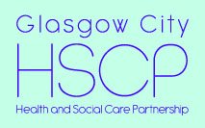

Glasgow City Health and Social Care Partnership

Summary of North West Locality Plan 2019 - 22

INTRODUCTION

Glasgow City Health and Social Care Partnership (GCHSCP) is required by the Public Bodies (Joint Working) (Scotland) Act 2014 to produce a Strategic Plan https://glasgowcity.hscp.scot/publication/gchscp-strategic-plan-2019-2022 for the health and social care services and functions delegated to the Integration Joint Board by Glasgow City Council and NHS Greater Glasgow and Clyde. These services are jointly delivered as the ‘Glasgow City Health and Social Care Partnership’ under the guidance of an Integration Joint Board.

The GCHSCP Strategic Plan covers health and social care services across the entire City. Each of the three local areas (North East, North West and South) that make up GCHSCP develop their own Locality Plan with partners including patients, service users, carers and the third and independent sectors. Locality Plans show how the Strategic Plan is being implemented locally and are updated each year to reflect feedback from stakeholders; ensuring services reflect local priorities, needs and community issues.

This document provides a summary of the North West Locality Plan 2019 - 2022. The full version can be viewed here:
https://glasgowcity.hscp.scot/sites/default/files/publications/ITEM%20No%2012%20-%20Draft%20HSCP%20Locality%20Plans%202019-22.pdf.

This summary provides information on key areas of performance across our care groups and sets out the strategic priorities and actions that are being implemented on a city wide basis and in North West Locality.

ABOUT North West lOCAlITY

Glasgow City is the largest HSCP in Scotland by population and budget and is responsible for health and social care provision across three localities in the City; North West, North East and South Glasgow. North West Locality covers a population of 206,483 people.

As well as having responsibility for supporting the delivery of the range of services set out within this plan to our local population, the Assistant Chief Officer for the North West Locality also has a lead responsibility within Glasgow City HSCP for managing all Adult Services which includes Mental Health, Learning Disability, Alcohol and Drugs Recovery, Housing and Homelessness, Prison Healthcare, Police Custody and Criminal Justice services. North West Locality has responsibility for managing Sexual Health Service that is hosted by Glasgow City HSCP on behalf of all HSCPs in Greater Glasgow and Clyde.

Health and Wellbeing
The Strategic Plan sets out the priorities for the HSCP in terms of prevention and early intervention. Whilst keeping people healthier for longer is one of the HSCP’s priorities, improving the health and wellbeing of the population requires consideration of the key causes of health inequalities. The HSCP recognises that within the City there are people severely affected by poverty and deprivation, and this is one of the causes of health inequalities that health and social care services must seek to alleviate.

Glasgow City HSCP understands that tackling health inequalities and achieving health equity requires the removal of barriers to accessing and delivering services that are sensitive to the social circumstances experiences by citizens. The HSCP is committed to working with our community planning partners to implement the NHS Greater Glasgow and Clyde Public Health Strategy, Turning the Tide through Prevention, which describes six priority actions for improving the public health of people across the Greater Glasgow and Clyde area. A copy of the Strategy can be found here: https://www.stor.scot.nhs.uk/handle/11289/579831.

The adult Health and Well Being Survey has been undertaken by the Health Board in NHSGGC on a three yearly basis since 1999. Below is some key data and trend information for North West Locality including the demographic profile from the 2018 Report.
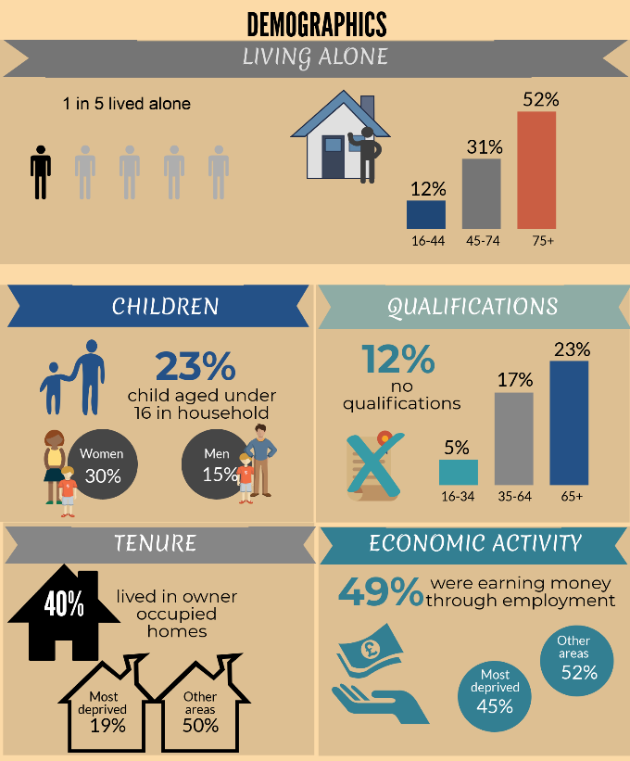
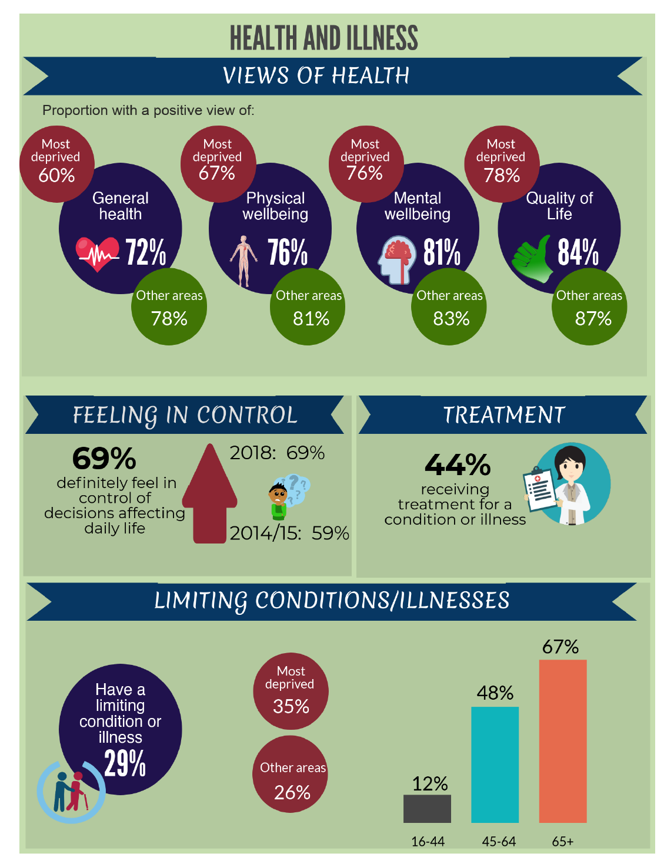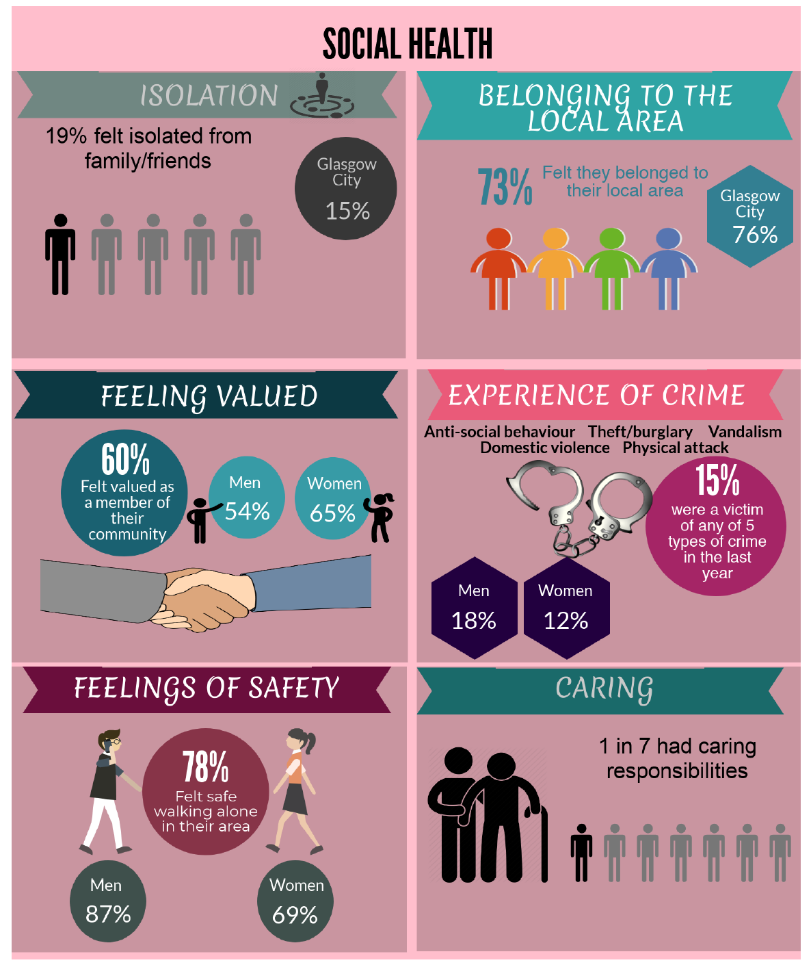
Full report: North West Glasgow - https://www.stor.scot.nhs.uk/handle/11289/579886

GCHSCP STRATEGIC PLAN 2019-2022
Strategic Priorities and Actions
The detailed priorities and actions set out in the GCHSCP Strategic Plan are grouped under five strategic priorities, namely:

- early intervention, prevention and harm reduction
- providing greater self-determination and choice
- shifting the balance of care
- enabling independent living for longer
- public protection

Locality Plan 2019-2022 Priorities and Actions
Priority activities and actions will be delivered consistently across each locality area and are identified as “city-wide”; however they will be delivered and monitored by each locality. Some specific actions will be delivered in a single locality, reflecting local needs and priorities.

A comprehensive list of city-wide and local strategic priorities and actions can be found in the full Plan here: https://glasgowcity.hscp.scot/sites/default/files/publications/GCHSCP_Strategic_Plan_2019_1.pdf

Key priorities for North West Locality for 2019 – 2022 include:

- Open the new £20m Woodside Health and Care Centre in order to deliver integrated health and social care services
- Develop a Parenting and Family Support Directory
- Continue to pilot use of WHO (World Health Organisation) suicide prevention community engagement toolkit in Drumchapel and implement Drumchapel Suicide Safer Communities Neighbourhood Action Plan
- Work with Registered Statutory Landlords to mitigate against rent arrears occurring from tenancy start dates and tenancy failures.
- Continue to develop Knightswood Connects - a community response to frailty, isolation and loneliness experienced by some older people living in the Knightswood area.
- Roll out palliative identification tool(SPAR) in Hawthorn House residential care home and monitor and develop clinical input at the new Victoria residential care home
- Explore the feasibility of finding alternative, suitable accommodation to Sandyford Sexual Health Services

Performance
GCHSCP produces an annual performance report which reflects on performance in relation to national and local indicators and commitments set out in the Strategic Plan. Performance is also measured at a care group and service level via a variety of internal and external governance arrangements.
Key achievements in North West Locality in 2018 -19 include:
- More people being supported to live as independently as possible at home and in the community
- Restructuring community services for older people into three neighbourhood teams to improve joint working with partners including GP clusters, Housing and third sector stakeholders
- Achieving the majority of waiting time and access targets

A comprehensive list of city-wide and local performance information can be found here in the Annual Performance Report 2018-2019 here: https://glasgowcity.hscp.scot/sites/default/files/publications/HSCP%20Annual%20Performance%20Report%202018%2019_0.pdf
Transformation Programmes
Delivery of effective and lasting transformation of health and social care services is central to the vision of Glasgow City HSCP. Transformation is not just changing how services are structured. Transformation is about making significant changes to how services are planned and delivered in partnership with people who use them. A number of important strategies and programmes are already under way that will transform how health and social care services in the City are delivered and experienced by patients, service users and carers. Whilst the Transformation Programmes are already delivering real and sustainable change for people in the City, further work is required.

Older People Services Transformation Programme

The strategy for older people and people with a physical disability signals a clear intention to shift the focus to enabling and supporting those who require assistance to enjoy the best quality of life possible, informed by choices they make for themselves. For older people’s health and social care this means a different attitude towards risk and its management across the entire system, particularly where older people themselves make a conscious choice to live with risk in the community. This approach will also apply to people with a physical disability. More information on the Older People Services Transformation Programme is available here: https://glasgowcity.hscp.scot/sites/default/files/publications/ITEM%20No%2007%20-%20Older%20Peoples%20Transformational%20Change%20Programme%202018-21_0.pdf
Adult Services Transformation Programme

In recent years in Adult Services there has been significant progress in shifting the balance of care and delivering more effective, community based services. Our strategy signals a clear intention to shift the focus towards more of a risk-enabling approach that maximises the opportunity for independent living, with a stronger emphasis on prevention, early intervention and supporting self-management of certain conditions. More information on the Adult Services Transformation Programme is available here: https://glasgowcity.hscp.scot/sites/default/files/publications/ITEM%20No%2006%20-%20Adult%20Services%20Transformational%20Change%20Programme%202018-2021_0.pdf
Children’s Services Transformation Programme

For Children’s Services our strategy aims not only to secure better outcomes and more positive destinations for children and young people but to enable Children’s Services to operate more efficiently and effectively across the City. The transformation programme for Children’s Services is designed to strengthen the local infrastructure to deliver a preventative strategy in the City. There is also a commitment and a determination to spend more of the IJB’s / GCHSCP’s resources in the City to ensure that where possible children and young people are helped to stay at home, in their neighbourhoods and in their local schools. To this end, the strategy is to seek to implement the aspirations of the Christie Commission, to avoid spending money in ‘failure demand’ and significantly shift money and interventions into the community. The Children’s Services Transformation Programme is available here: https://glasgowcity.hscp.scot/sites/default/files/publications/ITEM%20No%2006%20-%20Transformational%20Change%20Programme%20-%20Childrens%20Services%202018-21.pdf

Primary Care Improvement Plan
Glasgow City HSCP agreed a Primary Care Improvement Plan (PCIP) in Autumn 2018. The PCIP presents a major opportunity to transform primary care by supporting GPs to operate effectively as expert medical generalists. This involves GP’s leading multi-disciplinary teams, giving them more time to spend seeing patients and addressing the needs of the rising numbers of people with multiple and complex conditions. Our strategy includes enabling more support to be delivered in home and community settings and promoting greater self-management and choice to allow people to stay cared for appropriately and safely in the community for longer. More information on the PCIP can be found here:
https://glasgowcity.hscp.scot/sites/default/files/publications/ITEM%20No%2009%20-%20Primary%20Care%20Improvement%20Plan_0.pdf
SUPPORT FOR CARERS
The Carers (Scotland) Act 2016 came into force on 1st April 2018 and places additional duties on Integration Joint Boards. The Act can be found here: http://www.legislation.gov.uk/asp/2016/9/contents.
Carers and young carers have been fully engaged and involved in the development of the Glasgow Adult and Young Carer Strategies. There are well established locality carer forums and a city-wide Carer Reference Group who are represented on the Carer Strategic Planning Group and the city wide operational delivery group. Young carer engagement has been facilitated through the Young Carer Strategy Group. The appointment of a Carers Champion and plans for quarterly engagement events with wider groups of carers will provide a focus for carers to influence the implementation of the Act. More information on the implementation of the Carers (Scotland) Act 2016 can be found here:
https://glasgowcity.hscp.scot/sites/default/files/publications/ITEM%20No%2012%20-%20Implementing%20the%20Carers%20Scotland%20Act%202016_0.pdf

COMMUNITY ENGAGEMENT
The priorities and actions set out within North West Locality Plan have been informed by a broad range of community and service user engagement activity. This has included engagement on the priorities 2019- 22, consultation on Glasgow City IJB’s Strategic Plan 2019-22 and involving service users, carers, community groups and partner agencies in the development of a variety of service strategies and action plans. In particular, the North West Locality Engagement Forum (LEF) has been a catalyst for communication, engagement and participation. The North West LEF priorities for the next three years will be to:
- continue to have regular meetings to discuss and contribute to locality care group priorities, as well as topic focused discussions to encourage participation and involvement from the wider community;
- continue to promote greater representation of vulnerable people and groups;
- continue to work in partnership with North West Voluntary Sector Network, North West Youth Network and North West Mental Health, Wellbeing and Suicide Safer Communities Forum, as well as develop closer links with North West Recovery Communities, Carers Forum and Childcare Forum;
- lead city wide participation and create engagement opportunities around Adult service priorities and developments;
- support and encourage services and teams to engage and gather comments at the point of service delivery.

Further information about locality engagement in North West Glasgow can be found here: https://glasgowcity.hscp.scot/locality-engagement-forums
EQUALITiES
As a public body, the IJB is required under the Equality Act 2010 to publish its own set of equality outcomes. It is also required to report on progress in taking forward the equalities agenda and is expected to review policies and practices to ensure these eliminate discrimination, harassment and victimisation, and advance equality of opportunity and access for people with ‘protected characteristics’. Further information can be found in the Glasgow City HSCP Mainstreaming and Equalities Action Plan here:https://glasgowcity.hscp.scot/sites/default/files/publications/IJB_Meeting_20160321_Item_10_Equalities_Mainstreaming.pdf
CONTACT INFORMATION
For more information about this summary or to request it in an alternative format, please contact: May Simpson, Community Engagement Officer on 0141 314 6250 or email May.Simpson@ggc.scot.nhs.uk

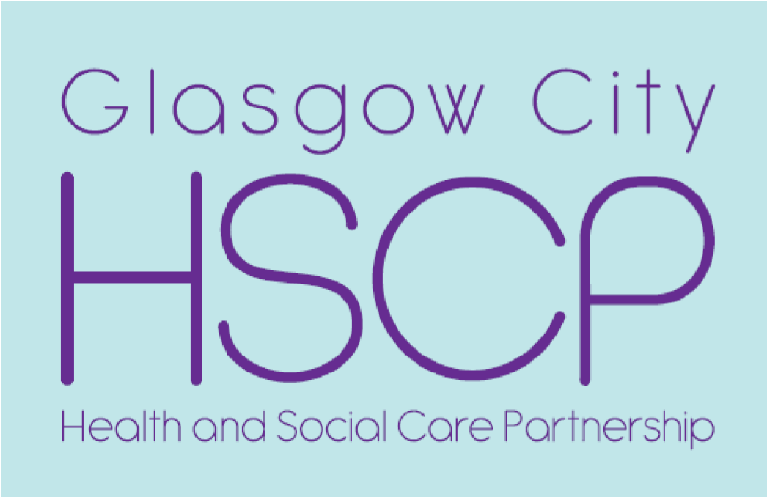
Review of Glasgow City HSCP Communications Strategy

Jason Mokrovich, Business Development Manager
Thursday, 7 November
www.glasgowcity.hscp.scot
@GCHSCP
Background
- Communications Strategy and Action Plan (January 2017)
- Further Improvement Action Plan (March 2017)
- Survey
- Review of Communications Strategy and Action Plan (Aug/Sept 2019)

Communications Strategy: What is it?
- Framework for Effective Communications (Internal and External)
- Communications Audience
- Communications Channels
- Action Plan
Communications Strategy Review: What and How?
- Share views on…
- our communications framework
- knowledge of the HSCP, IJB and their work
- how find out about the HSCP, IJB and their work & preferred comms channels
- the usefulness of our communications and
- how our communications can be improved
- Survey – open until 5 January 2020
- www.smartsurvey.co.uk/s/gchscp-comms
- www.glasgowcity.hscp.scot/gchscp-comms
- LEF/LEN Engagement
- Report to IJB in June 2020

Discussion Questions
- How do you get information about Glasgow City HSCP – its work and services?
- What are your five preferred ways for getting information about Glasgow City HSCP?
- What suggestions do you have on how we can improve our communications?

