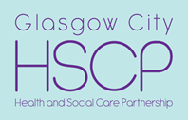
South Locality Engagment Session Report
Mental Health Services in South Glasgow
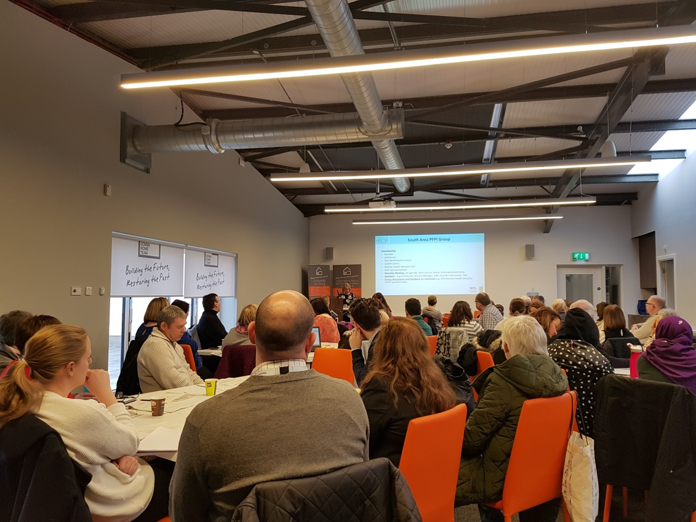
Report by:
Lisa Martin, Community Engagement Officer,
Glasgow HSCP South Locality
Who attended?

55 participants
10 staff members
3 speakers

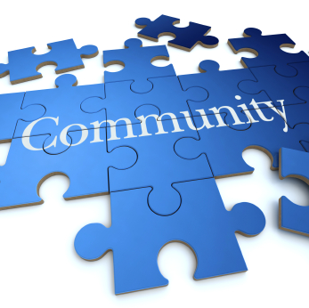 Community organisations and groups
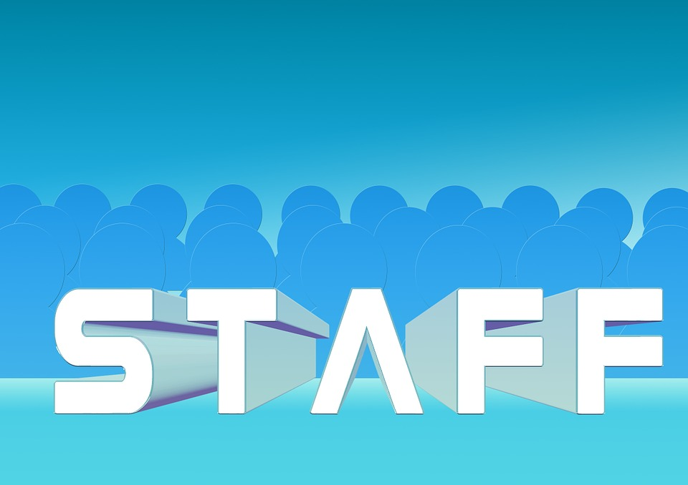 Staff from the HSCP and other partners
People with experience of using mental health services People from South Glasgow with an interest in finding out more about mental health services

Thursday 8th February 2018
10.30am – 1.00pm
Govan Home Conference Suite, Ibrox

- Background

Glasgow City Health and Social Care Partnership (HSCP) has a Participation and Engagement Strategy that sets out how it will engage with service users, patients, carers and the wider public https://glasgowcity.hscp.scot/publication/participation-and-engagement-strategy. South Locality has an engagement plan that includes a programme of public information sessions on different service areas and care groups.

The third public information session was timed to coincide with the release of the Five Year Strategy for Adult Mental Health Services NHS Greater Glasgow and Clyde 2018-2023 (Draft). The session comprised of three presentations from keynote speakers as well as round table discussion groups facilitated by an HSCP or a Mental Health Network member of staff. The three inputs were:

- Suicide Safer Communities Award, Paul Lafferty, Health Improvement Senior, HSCP South Locality
- Involving Service Users in Community Based Programmes, Shona Mackie, Capacity Building Officer, Mental Health Network
- Five Year Mental Health Strategy for NHS Greater Glasgow and Clyde, Katrina Phillips, Head of Adult Services, HSCP North East Locality
Participants were asked to give feedback on each presentation and specifically on the key strands of the Five Year Mental Health Strategy. A summary of each presentation and feedback from the round table discussions is given in the report below. A full copy of each presentation is available by contacting Lisa.Martin@ggc.scot.nhs.uk or 0141 427 8269.

- Suicide Safer Communities Initiative

Paul Lafferty explained the background to the Suicide Safer Communities Award, highlighting the work of the Choose Life Programme in Glasgow as a successful example of multi-agency working.

The Suicide Safer Communities Award is focussed on building sustainable, co-ordinated and collaborative approaches to suicide prevention, intervention and post-intervention across the city. North East Glasgow has an existing Suicide Prevention Forum and North West is in the process of developing one.

A seminar was held in South Glasgow in November 2017 and attended by 30 people from a range of organisations and groups. A further session to take forward the commitment to the Suicide Safer Communities Award will be held on 23rd February (provisional date) with a commitment to develop an action plan by June 2018. There will be on-going community engagement to increase representation from the wider community.
Feedback from Group Discussion:
- Not sure about the name ‘Suicide Safer Communities’ award, could that be misunderstood?
- A very worthwhile and positive initiative
- There are pockets of good practice in the city to use as examples e.g. Pillars work
- A complex and multi-faceted issue that needs to involve the Police, Education Services and also address the pressure of the current benefits/welfare reform agenda
- Staff from as many agencies as possible should have access to suicide prevention training; ‘suicide is everyone’s business’
- Most people who take their own lives are not known to mental health services so reaching this group needs to be done via partner organisations and structures
- Younger people are more at risk due to issues such as peer pressure, social media, sexuality and (as we heard) early onset of mental health issues such as anxiety and depression – schools must update their personal and social education programmes to include mental health as a mainstream health issue in same way as other physical health issues – tackling stigma is key. Is this something the forum would tackle?
- The forum (if it is set up) should also look at support for people bereaved as a result of suicide
- Can we not look at North East and North West as examples and develop similar forum?

- Involving Service Users in Community Based Programmes

Shona Mackie gave a detailed presentation on opportunities in South Glasgow to involve users of mental health services in planning and delivering a variety of community based programmes and services. The Patient Focus Public Involvement (PFPI) Group is a partnership between service users, community and third sector partners, the Mental Health Network (MHN) and the HSCP. It meets monthly and senior managers, service planners and decision makers are routinely invited to attend the group to listen to the experience of service users and work together to address issues or concerns. The PFPI Group has been instrumental in driving a number of other initiatives including carer engagement and involvement, volunteering opportunities and the Design in the Dale Art Strategy Group. The MHN also work locally to gather patient and service user feedback and works with the HSCP to involve them in planning and delivering services. This includes in-patient and community settings. The MHN continues to support mental health service users to share their experiences, give feedback and explore opportunities to become further involved in the variety of programmes available.

Feedback from Group Discussion:
- Good to hear about the number of activities on offer
- There can sometimes be a wait to get access to mental health services, these activities could be offered to people in the interim so that they don’t lose hope – a form of ‘pre-engagement’
- Regular networking events for services to find out what is going on across the South
- Some services are not available across the whole South – ideally these gaps will be filled in the future
- Great to hear that the voice of patients, service users and carers is being listened to through the PFPI group and through the patient conversations
- Good example is being set as people can see that patients, service users and carers can influence change
- The evaluation and quality assurance of this work is good – e.g. Design in the Dale Art Strategy has a high profile
- Is the PFPI Group open to everyone – details provided on how to contact them

- Draft Five Year Mental Health Strategy

Katrina Phillips, Head of Adult Services, Glasgow HSCP North East Locality delivered a comprehensive presentation on the draft mental health strategy in lieu of Fiona McNeil, Head of Adult Services in South Locality who was unable to attend and had submitted her apologies. The presentation set out the context within which mental health services are currently delivered, the key challenges, the case for change and a description of the key strands within the strategy which are:

Prevention Recovery
Unscheduled care Community
Inpatient beds Workforce
Users and carers Finance
Risks and governance

Katrina explained that the vision for mental health services is to offer a comprehensive, high quality and person centred service that is increasingly community based, gradually reducing the number of inpatient stays and offering patients and service users a wider range of choices, options and treatment.

In particular Katrina spoke about the strong focus on prevention throughout the strategy, especially given the evidence that 50% of adult mental health issues have begun by the age of 15 years and 75% have begun by the age of 18 years. There is also strong evidence that early intervention can reduce levels of other health inequalities such as incidences of drug and alcohol use, smoking, teenage pregnancy and poor diet. The recovery approach is also a core aspect of the strategy and a number of models are being explored. There are good examples through recovery hubs, recovery communities, peer support groups and recovery cafes. Overall, the strategy proposes to reduce the number of inpatient beds, both short stay and longer stay in favour of a more comprehensive suite of services delivered in the community, in some cases by experienced third sector partners. Any savings made through the reconfiguration of inpatient services will be reinvested in community based services.

There has already been engagement with mental health service users, carers, community and third sector partners to develop the draft strategy but feedback at a locality level is equally important and participants were invited to share their views in the discussion groups.

Feedback from Discussion:
- Prevention was widely viewed as being essential to the success of any strategy to reshape mental health services – liaison with education and social work children and family services in particular
- The most empowering thing is feeling in control – talking therapies and other forms of early intervention are not widely enough available –viewed as more holistic alternative to medication
- Some people do have life-long ill health and will require medication and/or in patient treatment – services need to be person centred and not dictated by the resources available or the desire to have a particular ‘model’
- Recovery is an essential element but means different things to different people – promoting self-management is fine and will work for some – some conditions you can recover from but some people need medication and/or clinical support to stay well
- Will staff be able to develop individualised recovery plans for everyone? Aware of capacity issues within services
- Concern that young people are not being picked up early enough and that services and schools are not trained to support them
- Concern was expressed about the transition from youth to adult mental health services not being as smooth as it should be
- Good to hear that any savings will be reinvested in community services
- There should not be a reduction in inpatient beds unless absolutely certain the community supports are in place
- More generally, the community and third sector is reducing – opportunities to get involved in wider community activity is just not there – leisure centres, lunch clubs, community groups are at full capacity or having their funding cut
- Other public services have a big role to play – liaison between housing providers and HSCP services is key (Housing Options)
- Worries about welfare reform are a significant cause of distress/anxiety – DWP staff need to be better trained and people need to be supported through the process, including appeals
- The biggest issue is out of hours access to services – often when people are in crisis – need to extend community mental health team operating hours
- Strategy needs to look at support for people on discharge from hospital – continuity of care
- Training and education for mainstream staff to identify distress and suicidal behaviour
- Different anecdotal experiences of Out of Hours service, mostly positive but one example of a person left waiting until next day
- Reshaping local services is positive but needs to be in the context of a wider programme of awareness raising/information/tackling stigma around mental health
- Mental health is still very much a taboo within the BME community – services and staff, especially GPs need to be pro-active in reaching out to people – education and awareness raising using existing groups is required
- If you are not known to services you will find it very difficult to access specialist services if/when you need them
- Strategy must respond to carers needs
- Addressing stigma is a huge public health issue – people don’t need to access a specific mental health service or group however all services and groups should be inclusive of people with mental health issues
- Examples such as Crisis Café’s welcome but change the name to make them more inclusive
- Good use of social media to address stigma/discrimination as an option
- Overall people want to continue to be informed about the roll out of the strategy as the changes/reforms are made

5.Questions

Members of Platforum, a local mental health service user forum asked why they had not known about the draft strategy until now. Katrina Phillips re-assured them that the draft had only just been published, having gone to the Integrated Joint Board of the HSCP on the 24th January, and that the locality information sessions were part of a wider programme of engagement that had already included a wide range of community and third sector partners. The HSCP is committed to engaging with local groups and an offer was extended to meet with Platforum out with the session to discuss this further.

- Next Steps

Platforum, a local mental health service user forum agreed to work alongside the HSCP to deliver a future session focussing on the draft Mental Health Strategy in more detail.

The feedback from the session will be made into a report and shared with the Head of Adult Services in South, the South Locality Executive Team, senior staff within the HSCP and everyone who is part of the South Locality Engagement Network.

The participants were thanked for their contribution and invited to leave their contact details in order to receive a copy of the session report and to join the South Locality Engagement Network for news, updates and invitations to events from the HSCP.
For more information on any aspect of our locality engagement arrangements, to request this newsletter in an alternative format or to unsubscribe from this mailing list please contact Lisa Martin, Community Engagement Officer at: Lisa.Martin@ggc.scot.nhs.uk or call 0141 427 8269. Thank you.
For further information or to request this report in an alternative format please contact:
For more information on any aspect of our locality engagement arrangements, to request this newsletter in an alternative format or to unsubscribe from this mailing list please contact Lisa Martin, Community Engagement Officer at: Lisa.Martin@ggc.scot.nhs.uk or call 0141 427 8269. Thank you.

Lisa Martin
Community Engagement Officer (HSCP South Locality)
Email: Lisa.Martin@ggc.scot.nhs.uk
Phone : 0141 427 8269

